|  |  |
| --- | --- |
| Date | 27 November 2022 |
| Team ID | PNT2022TMID48304 |
| Project Name | Project - IoT Based Smart Crop Protection System for Agriculture |

**TECHNICAL AIRCHITECTURE/STACK**

**THIRD PARTY API’S:**

An Agriculture API is an Application Programming Interface that enables developers to interact with data and services pertaining to agriculture.

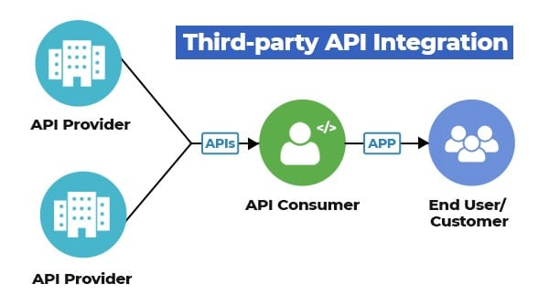

**1. Plant.id API**

Plant.id enables users to identify plants from images. The Plant.id API returns plant identification data in JSON format, using photos recognizable by deep Machine Learning.

### 2. Open Food Network API

Open Food Network is a software Platform for selling produce online. Farmers can use the e-commerce software solution to host their own online shop, monitor sales data, and collaborate with other local farmers to create regional food systems.

### 3. The Rainery API

[The Rainery API](https://www.programmableweb.com/api/therainery-rest-api-v1) provides access to raw weather forecasts from trusted Meteorological Institutes including NOAA, Météo France, DWD. The API offers methods to retrieve atmospheric forecasts, marine forecasts, and astronomical data.

### 4. Agriness S4 Farm API

Agriness provides a farm animal production, information, and management platform. The Agriness S4 is designed to increase production efficiency in pig farms. The [S4 API](https://www.programmableweb.com/api/agriness-s4-farm-rest-api-v1) integrates livestock management capabilities with direct access to accounts, entities, and farm information.